Green Society Public School
D-12
Ratnanagar-7, Sauraha, Chitwan
Annual Examination-2082
Class: Nursery Time: - 2 hrs. F.M.: 50
Sub: Rhymes & Conv.
Hello! Good Morning/Good Afternoon
1. What is your name? 5
2. How old are you? 5
3. What is your principal's name? 5
4. What is your class teacher's name? 5
5. Identify the pictures? 5


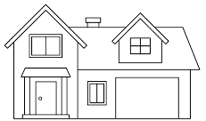

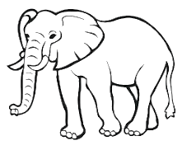

6. Rhymes. 5
7. Dance. 5
8. Neat and Clean. 5
9. Regularity. 5
The End

